**ADS Homework Runtime Report**

|  |  |
| --- | --- |
| Name | Student ID |
| Oussama Shebaro | 22004122 |
| Mohammed Adel (M.A) Sinnokrot | 22005106 |
| Ahmad Bilal Bin Syukran Saadnudin | 22007978 |
| Muhammad Haikal Bin Anuar | 22007153 |

Machine 1

CPU: Intel Core i5-12500H  
RAM: 16GB 4800MT/s  
GPU: NVDIA GeForce RTX 3050 Mobile  
Runtime:

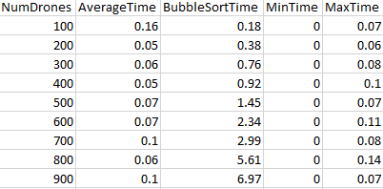

Machine 2

CPU: Intel Core i7-9750H  
RAM: 16GB 2667MT/s  
GPU: NVIDIA GeForce GTX 1650 Mobile  
Runtime:

Machine 3

CPU: Intel Core i7-13620H  
RAM: 16GB 5200MT/s  
GPU: NVIDIA GeForce RTX 4060 Mobile   
Runtime:  
  
